Họ và tên: Lý Chí Chương
Lớp: 11_ĐHCNPM2
BÁO CÁO BÀI TẬP TUẦN 8
Bài 1:
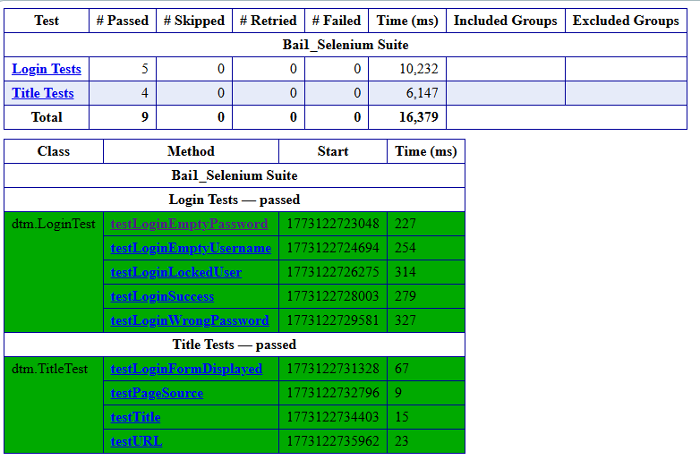
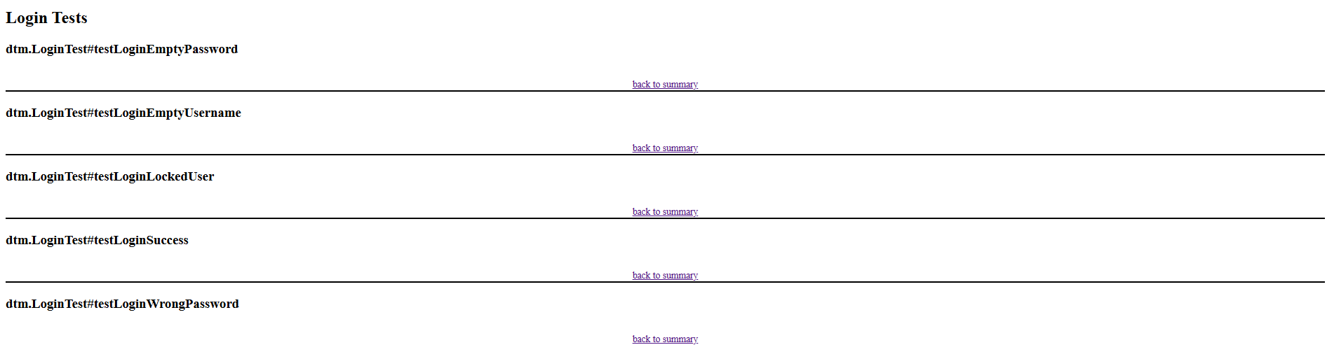
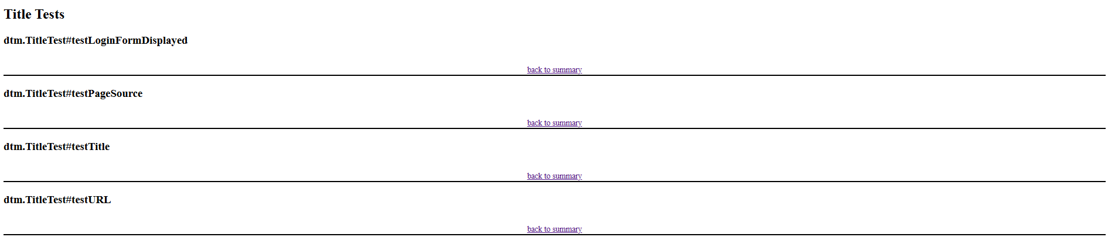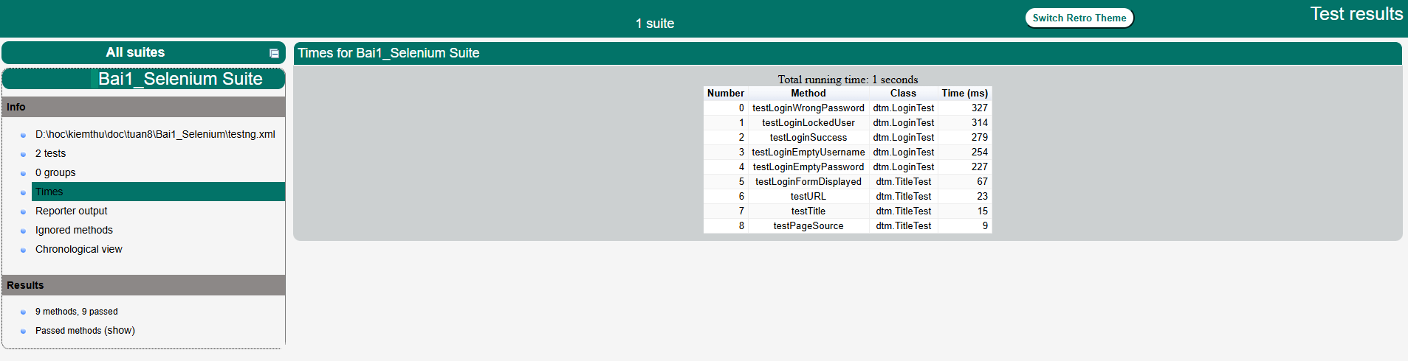
Bài 2:
Cấu hình testng.xml chỉ chạy nhóm 'smoke'
Console ouput:
[INFO] Scanning for projects...
[INFO]
[INFO] ---------------------< com.example:Bai1_Selenium >----------------------
[INFO] Building Bai1_Selenium 0.0.1-SNAPSHOT
[INFO] from pom.xml
[INFO] --------------------------------[ jar ]---------------------------------
[INFO]
[INFO] --- clean:3.5.0:clean (default-clean) @ Bai1_Selenium ---
[INFO] Deleting D:\hoc\kiemthu\doc\tuan8\Bai1_Selenium\target
[INFO]
[INFO] --- resources:3.3.1:resources (default-resources) @ Bai1_Selenium ---
[INFO] Copying 1 resource from src\main\resources to target\classes
[INFO] Copying 0 resource from src\main\resources to target\classes
[INFO]
[INFO] --- compiler:3.14.1:compile (default-compile) @ Bai1_Selenium ---
[INFO] Recompiling the module because of changed source code.
[INFO] Compiling 1 source file with javac [debug parameters release 21] to target\classes
[INFO]
[INFO] --- resources:3.3.1:testResources (default-testResources) @ Bai1_Selenium ---
[INFO] skip non existing resourceDirectory D:\hoc\kiemthu\doc\tuan8\Bai1_Selenium\src\test\resources
[INFO]
[INFO] --- compiler:3.14.1:testCompile (default-testCompile) @ Bai1_Selenium ---
[INFO] Recompiling the module because of changed dependency.
[INFO] Compiling 7 source files with javac [debug parameters release 21] to target\test-classes
[INFO]
[INFO] --- surefire:3.5.4:test (default-test) @ Bai1_Selenium ---
[INFO] Using configured provider org.apache.maven.surefire.testng.TestNGProvider
[INFO]
[INFO] -------------------------------------------------------
[INFO] T E S T S
[INFO] -------------------------------------------------------
[INFO] Running TestSuite
13:41:59.760 [main] INFO io.github.bonigarcia.wdm.WebDriverManager -- Using chromedriver 145.0.7632.117 (resolved driver for Chrome 145)
13:41:59.806 [main] INFO io.github.bonigarcia.wdm.WebDriverManager -- Exporting webdriver.chrome.driver as C:\Users\USER\.cache\selenium\chromedriver\win64\145.0.7632.117\chromedriver.exe
.\mvnw.cmd : Mar 10, 2026 1:42:00 PM
org.openqa.selenium.devtools.CdpVersionFinder findNearestMatch
At line:1 char:72
+ ... ots -ErrorAction SilentlyContinue; .\mvnw.cmd clean test 2>&1 | Tee-O ...
+ ~~~~~~~~~~~~~~~~~~~~~~~~~~
+ CategoryInfo : NotSpecified: (Mar 10, 2026 1:...indNearestMatch
:String) [], RemoteException
+ FullyQualifiedErrorId : NativeCommandError

WARNING: Unable to find CDP implementation matching 145
Mar 10, 2026 1:42:00 PM org.openqa.selenium.chromium.ChromiumDriver
lambda$new$4
WARNING: Unable to find version of CDP to use for 145.0.7632.161. You may need
to include a dependency on a specific version of the CDP using something
similar to `org.seleniumhq.selenium:selenium-devtools-v86:4.37.0` where the
version ("v86") matches the version of the chromium-based browser you're using
and the version number of the artifact is the same as Selenium's.
[SCREENSHOT] Saved: D:\hoc\kiemthu\doc\tuan8\Bai1_Selenium\screenshots\LoginTest_testLoginSuccess.png
13:42:02.395 [main] INFO io.github.bonigarcia.wdm.WebDriverManager -- Using chromedriver 145.0.7632.117 (resolved driver for Chrome 145)
13:42:02.401 [main] INFO io.github.bonigarcia.wdm.WebDriverManager -- Exporting webdriver.chrome.driver as C:\Users\USER\.cache\selenium\chromedriver\win64\145.0.7632.117\chromedriver.exe
Mar 10, 2026 1:42:03 PM org.openqa.selenium.devtools.CdpVersionFinder
findNearestMatch
WARNING: Unable to find CDP implementation matching 145
Mar 10, 2026 1:42:03 PM org.openqa.selenium.chromium.ChromiumDriver
lambda$new$4
WARNING: Unable to find version of CDP to use for 145.0.7632.161. You may need
to include a dependency on a specific version of the CDP using something
similar to `org.seleniumhq.selenium:selenium-devtools-v86:4.37.0` where the
version ("v86") matches the version of the chromium-based browser you're using
and the version number of the artifact is the same as Selenium's.
[SCREENSHOT] Saved: D:\hoc\kiemthu\doc\tuan8\Bai1_Selenium\screenshots\CartTest_testAddToCart.png
13:42:04.598 [main] INFO io.github.bonigarcia.wdm.WebDriverManager -- Using chromedriver 145.0.7632.117 (resolved driver for Chrome 145)
13:42:04.602 [main] INFO io.github.bonigarcia.wdm.WebDriverManager -- Exporting webdriver.chrome.driver as C:\Users\USER\.cache\selenium\chromedriver\win64\145.0.7632.117\chromedriver.exe
Mar 10, 2026 1:42:05 PM org.openqa.selenium.devtools.CdpVersionFinder
findNearestMatch
WARNING: Unable to find CDP implementation matching 145
Mar 10, 2026 1:42:05 PM org.openqa.selenium.chromium.ChromiumDriver
lambda$new$4
WARNING: Unable to find version of CDP to use for 145.0.7632.161. You may need
to include a dependency on a specific version of the CDP using something
similar to `org.seleniumhq.selenium:selenium-devtools-v86:4.37.0` where the
version ("v86") matches the version of the chromium-based browser you're using
and the version number of the artifact is the same as Selenium's.
[SCREENSHOT] Saved: D:\hoc\kiemthu\doc\tuan8\Bai1_Selenium\screenshots\CheckoutTest_testCheckoutSuccess.png
[INFO] Tests run: 3, Failures: 0, Errors: 0, Skipped: 0, Time elapsed: 8.267 s -- in TestSuite
[INFO]
[INFO] Results:
[INFO]
[INFO] Tests run: 3, Failures: 0, Errors: 0, Skipped: 0
[INFO]
[INFO] ------------------------------------------------------------------------
[INFO] BUILD SUCCESS
[INFO] ------------------------------------------------------------------------
[INFO] Total time: 12.823 s
[INFO] Finished at: 2026-03-10T13:42:07+07:00
[INFO] ------------------------------------------------------------------------
Cấu hình lại testng.xml chạy nhóm 'regression’
console output:
[INFO] Scanning for projects...
[INFO]
[INFO] ---------------------< com.example:Bai1_Selenium >----------------------
[INFO] Building Bai1_Selenium 0.0.1-SNAPSHOT
[INFO] from pom.xml
[INFO] --------------------------------[ jar ]---------------------------------
[INFO]
[INFO] --- clean:3.5.0:clean (default-clean) @ Bai1_Selenium ---
[INFO] Deleting D:\hoc\kiemthu\doc\tuan8\Bai1_Selenium\target
[INFO]
[INFO] --- resources:3.3.1:resources (default-resources) @ Bai1_Selenium ---
[INFO] Copying 1 resource from src\main\resources to target\classes
[INFO] Copying 0 resource from src\main\resources to target\classes
[INFO]
[INFO] --- compiler:3.14.1:compile (default-compile) @ Bai1_Selenium ---
[INFO] Recompiling the module because of changed source code.
[INFO] Compiling 1 source file with javac [debug parameters release 21] to target\classes
[INFO]
[INFO] --- resources:3.3.1:testResources (default-testResources) @ Bai1_Selenium ---
[INFO] skip non existing resourceDirectory D:\hoc\kiemthu\doc\tuan8\Bai1_Selenium\src\test\resources
[INFO]
[INFO] --- compiler:3.14.1:testCompile (default-testCompile) @ Bai1_Selenium ---
[INFO] Recompiling the module because of changed dependency.
[INFO] Compiling 7 source files with javac [debug parameters release 21] to target\test-classes
[INFO]
[INFO] --- surefire:3.5.4:test (default-test) @ Bai1_Selenium ---
[INFO] Using configured provider org.apache.maven.surefire.testng.TestNGProvider
[INFO]
[INFO] -------------------------------------------------------
[INFO] T E S T S
[INFO] -------------------------------------------------------
[INFO] Running TestSuite
13:42:48.471 [main] INFO io.github.bonigarcia.wdm.WebDriverManager -- Using chromedriver 145.0.7632.117 (resolved driver for Chrome 145)
13:42:48.519 [main] INFO io.github.bonigarcia.wdm.WebDriverManager -- Exporting webdriver.chrome.driver as C:\Users\USER\.cache\selenium\chromedriver\win64\145.0.7632.117\chromedriver.exe
.\mvnw.cmd : Mar 10, 2026 1:42:49 PM
org.openqa.selenium.devtools.CdpVersionFinder findNearestMatch
At line:1 char:72
+ ... ots -ErrorAction SilentlyContinue; .\mvnw.cmd clean test 2>&1 | Tee-O ...
+ ~~~~~~~~~~~~~~~~~~~~~~~~~~
+ CategoryInfo : NotSpecified: (Mar 10, 2026 1:...indNearestMatch
:String) [], RemoteException
+ FullyQualifiedErrorId : NativeCommandError

WARNING: Unable to find CDP implementation matching 145
Mar 10, 2026 1:42:49 PM org.openqa.selenium.chromium.ChromiumDriver
lambda$new$4
WARNING: Unable to find version of CDP to use for 145.0.7632.161. You may need
to include a dependency on a specific version of the CDP using something
similar to `org.seleniumhq.selenium:selenium-devtools-v86:4.37.0` where the
version ("v86") matches the version of the chromium-based browser you're using
and the version number of the artifact is the same as Selenium's.
[SCREENSHOT] Saved: D:\hoc\kiemthu\doc\tuan8\Bai1_Selenium\screenshots\LoginTest_testLoginEmptyPassword.png
13:42:50.876 [main] INFO io.github.bonigarcia.wdm.WebDriverManager -- Using chromedriver 145.0.7632.117 (resolved driver for Chrome 145)
13:42:50.890 [main] INFO io.github.bonigarcia.wdm.WebDriverManager -- Exporting webdriver.chrome.driver as C:\Users\USER\.cache\selenium\chromedriver\win64\145.0.7632.117\chromedriver.exe
Mar 10, 2026 1:42:51 PM org.openqa.selenium.devtools.CdpVersionFinder
findNearestMatch
WARNING: Unable to find CDP implementation matching 145
Mar 10, 2026 1:42:51 PM org.openqa.selenium.chromium.ChromiumDriver
lambda$new$4
WARNING: Unable to find version of CDP to use for 145.0.7632.161. You may need
to include a dependency on a specific version of the CDP using something
similar to `org.seleniumhq.selenium:selenium-devtools-v86:4.37.0` where the
version ("v86") matches the version of the chromium-based browser you're using
and the version number of the artifact is the same as Selenium's.
[SCREENSHOT] Saved: D:\hoc\kiemthu\doc\tuan8\Bai1_Selenium\screenshots\LoginTest_testLoginEmptyUsername.png
13:42:52.776 [main] INFO io.github.bonigarcia.wdm.WebDriverManager -- Using chromedriver 145.0.7632.117 (resolved driver for Chrome 145)
13:42:52.789 [main] INFO io.github.bonigarcia.wdm.WebDriverManager -- Exporting webdriver.chrome.driver as C:\Users\USER\.cache\selenium\chromedriver\win64\145.0.7632.117\chromedriver.exe
Mar 10, 2026 1:42:53 PM org.openqa.selenium.devtools.CdpVersionFinder
findNearestMatch
WARNING: Unable to find CDP implementation matching 145
Mar 10, 2026 1:42:53 PM org.openqa.selenium.chromium.ChromiumDriver
lambda$new$4
WARNING: Unable to find version of CDP to use for 145.0.7632.161. You may need
to include a dependency on a specific version of the CDP using something
similar to `org.seleniumhq.selenium:selenium-devtools-v86:4.37.0` where the
version ("v86") matches the version of the chromium-based browser you're using
and the version number of the artifact is the same as Selenium's.
[SCREENSHOT] Saved: D:\hoc\kiemthu\doc\tuan8\Bai1_Selenium\screenshots\LoginTest_testLoginLockedUser.png
13:42:54.906 [main] INFO io.github.bonigarcia.wdm.WebDriverManager -- Using chromedriver 145.0.7632.117 (resolved driver for Chrome 145)
13:42:54.918 [main] INFO io.github.bonigarcia.wdm.WebDriverManager -- Exporting webdriver.chrome.driver as C:\Users\USER\.cache\selenium\chromedriver\win64\145.0.7632.117\chromedriver.exe
Mar 10, 2026 1:42:55 PM org.openqa.selenium.devtools.CdpVersionFinder
findNearestMatch
WARNING: Unable to find CDP implementation matching 145
Mar 10, 2026 1:42:55 PM org.openqa.selenium.chromium.ChromiumDriver
lambda$new$4
WARNING: Unable to find version of CDP to use for 145.0.7632.161. You may need
to include a dependency on a specific version of the CDP using something
similar to `org.seleniumhq.selenium:selenium-devtools-v86:4.37.0` where the
version ("v86") matches the version of the chromium-based browser you're using
and the version number of the artifact is the same as Selenium's.
[SCREENSHOT] Saved: D:\hoc\kiemthu\doc\tuan8\Bai1_Selenium\screenshots\LoginTest_testLoginSuccess.png
13:42:57.251 [main] INFO io.github.bonigarcia.wdm.WebDriverManager -- Using chromedriver 145.0.7632.117 (resolved driver for Chrome 145)
13:42:57.259 [main] INFO io.github.bonigarcia.wdm.WebDriverManager -- Exporting webdriver.chrome.driver as C:\Users\USER\.cache\selenium\chromedriver\win64\145.0.7632.117\chromedriver.exe
Mar 10, 2026 1:42:57 PM org.openqa.selenium.devtools.CdpVersionFinder
findNearestMatch
WARNING: Unable to find CDP implementation matching 145
Mar 10, 2026 1:42:57 PM org.openqa.selenium.chromium.ChromiumDriver
lambda$new$4
WARNING: Unable to find version of CDP to use for 145.0.7632.161. You may need
to include a dependency on a specific version of the CDP using something
similar to `org.seleniumhq.selenium:selenium-devtools-v86:4.37.0` where the
version ("v86") matches the version of the chromium-based browser you're using
and the version number of the artifact is the same as Selenium's.
[SCREENSHOT] Saved: D:\hoc\kiemthu\doc\tuan8\Bai1_Selenium\screenshots\LoginTest_testLoginWrongPassword.png
13:42:59.272 [main] INFO io.github.bonigarcia.wdm.WebDriverManager -- Using chromedriver 145.0.7632.117 (resolved driver for Chrome 145)
13:42:59.278 [main] INFO io.github.bonigarcia.wdm.WebDriverManager -- Exporting webdriver.chrome.driver as C:\Users\USER\.cache\selenium\chromedriver\win64\145.0.7632.117\chromedriver.exe
Mar 10, 2026 1:42:59 PM org.openqa.selenium.devtools.CdpVersionFinder
findNearestMatch
WARNING: Unable to find CDP implementation matching 145
Mar 10, 2026 1:42:59 PM org.openqa.selenium.chromium.ChromiumDriver
lambda$new$4
WARNING: Unable to find version of CDP to use for 145.0.7632.161. You may need
to include a dependency on a specific version of the CDP using something
similar to `org.seleniumhq.selenium:selenium-devtools-v86:4.37.0` where the
version ("v86") matches the version of the chromium-based browser you're using
and the version number of the artifact is the same as Selenium's.
[SCREENSHOT] Saved: D:\hoc\kiemthu\doc\tuan8\Bai1_Selenium\screenshots\CartTest_testAddToCart.png
13:43:01.393 [main] INFO io.github.bonigarcia.wdm.WebDriverManager -- Using chromedriver 145.0.7632.117 (resolved driver for Chrome 145)
13:43:01.398 [main] INFO io.github.bonigarcia.wdm.WebDriverManager -- Exporting webdriver.chrome.driver as C:\Users\USER\.cache\selenium\chromedriver\win64\145.0.7632.117\chromedriver.exe
Mar 10, 2026 1:43:02 PM org.openqa.selenium.devtools.CdpVersionFinder
findNearestMatch
WARNING: Unable to find CDP implementation matching 145
Mar 10, 2026 1:43:02 PM org.openqa.selenium.chromium.ChromiumDriver
lambda$new$4
WARNING: Unable to find version of CDP to use for 145.0.7632.161. You may need
to include a dependency on a specific version of the CDP using something
similar to `org.seleniumhq.selenium:selenium-devtools-v86:4.37.0` where the
version ("v86") matches the version of the chromium-based browser you're using
and the version number of the artifact is the same as Selenium's.
[SCREENSHOT] Saved: D:\hoc\kiemthu\doc\tuan8\Bai1_Selenium\screenshots\CartTest_testCartPageDisplaysItem.png
13:43:03.567 [main] INFO io.github.bonigarcia.wdm.WebDriverManager -- Using chromedriver 145.0.7632.117 (resolved driver for Chrome 145)
13:43:03.575 [main] INFO io.github.bonigarcia.wdm.WebDriverManager -- Exporting webdriver.chrome.driver as C:\Users\USER\.cache\selenium\chromedriver\win64\145.0.7632.117\chromedriver.exe
Mar 10, 2026 1:43:04 PM org.openqa.selenium.devtools.CdpVersionFinder
findNearestMatch
WARNING: Unable to find CDP implementation matching 145
Mar 10, 2026 1:43:04 PM org.openqa.selenium.chromium.ChromiumDriver
lambda$new$4
WARNING: Unable to find version of CDP to use for 145.0.7632.161. You may need
to include a dependency on a specific version of the CDP using something
similar to `org.seleniumhq.selenium:selenium-devtools-v86:4.37.0` where the
version ("v86") matches the version of the chromium-based browser you're using
and the version number of the artifact is the same as Selenium's.
[SCREENSHOT] Saved: D:\hoc\kiemthu\doc\tuan8\Bai1_Selenium\screenshots\CartTest_testRemoveFromCart.png
13:43:05.685 [main] INFO io.github.bonigarcia.wdm.WebDriverManager -- Using chromedriver 145.0.7632.117 (resolved driver for Chrome 145)
13:43:05.692 [main] INFO io.github.bonigarcia.wdm.WebDriverManager -- Exporting webdriver.chrome.driver as C:\Users\USER\.cache\selenium\chromedriver\win64\145.0.7632.117\chromedriver.exe
Mar 10, 2026 1:43:06 PM org.openqa.selenium.devtools.CdpVersionFinder
findNearestMatch
WARNING: Unable to find CDP implementation matching 145
Mar 10, 2026 1:43:06 PM org.openqa.selenium.chromium.ChromiumDriver
lambda$new$4
WARNING: Unable to find version of CDP to use for 145.0.7632.161. You may need
to include a dependency on a specific version of the CDP using something
similar to `org.seleniumhq.selenium:selenium-devtools-v86:4.37.0` where the
version ("v86") matches the version of the chromium-based browser you're using
and the version number of the artifact is the same as Selenium's.
[SCREENSHOT] Saved: D:\hoc\kiemthu\doc\tuan8\Bai1_Selenium\screenshots\CheckoutTest_testCheckoutMissingFirstName.png
13:43:07.889 [main] INFO io.github.bonigarcia.wdm.WebDriverManager -- Using chromedriver 145.0.7632.117 (resolved driver for Chrome 145)
13:43:07.895 [main] INFO io.github.bonigarcia.wdm.WebDriverManager -- Exporting webdriver.chrome.driver as C:\Users\USER\.cache\selenium\chromedriver\win64\145.0.7632.117\chromedriver.exe
Mar 10, 2026 1:43:08 PM org.openqa.selenium.devtools.CdpVersionFinder
findNearestMatch
WARNING: Unable to find CDP implementation matching 145
Mar 10, 2026 1:43:08 PM org.openqa.selenium.chromium.ChromiumDriver
lambda$new$4
WARNING: Unable to find version of CDP to use for 145.0.7632.161. You may need
to include a dependency on a specific version of the CDP using something
similar to `org.seleniumhq.selenium:selenium-devtools-v86:4.37.0` where the
version ("v86") matches the version of the chromium-based browser you're using
and the version number of the artifact is the same as Selenium's.
[SCREENSHOT] Saved: D:\hoc\kiemthu\doc\tuan8\Bai1_Selenium\screenshots\CheckoutTest_testCheckoutMissingPostalCode.png
13:43:10.247 [main] INFO io.github.bonigarcia.wdm.WebDriverManager -- Using chromedriver 145.0.7632.117 (resolved driver for Chrome 145)
13:43:10.257 [main] INFO io.github.bonigarcia.wdm.WebDriverManager -- Exporting webdriver.chrome.driver as C:\Users\USER\.cache\selenium\chromedriver\win64\145.0.7632.117\chromedriver.exe
Mar 10, 2026 1:43:10 PM org.openqa.selenium.devtools.CdpVersionFinder
findNearestMatch
WARNING: Unable to find CDP implementation matching 145
Mar 10, 2026 1:43:10 PM org.openqa.selenium.chromium.ChromiumDriver
lambda$new$4
WARNING: Unable to find version of CDP to use for 145.0.7632.161. You may need
to include a dependency on a specific version of the CDP using something
similar to `org.seleniumhq.selenium:selenium-devtools-v86:4.37.0` where the
version ("v86") matches the version of the chromium-based browser you're using
and the version number of the artifact is the same as Selenium's.
[SCREENSHOT] Saved: D:\hoc\kiemthu\doc\tuan8\Bai1_Selenium\screenshots\CheckoutTest_testCheckoutSuccess.png
[INFO] Tests run: 11, Failures: 0, Errors: 0, Skipped: 0, Time elapsed: 25.19 s -- in TestSuite
[INFO]
[INFO] Results:
[INFO]
[INFO] Tests run: 11, Failures: 0, Errors: 0, Skipped: 0
[INFO]
[INFO] ------------------------------------------------------------------------
[INFO] BUILD SUCCESS
[INFO] ------------------------------------------------------------------------
[INFO] Total time: 30.640 s
[INFO] Finished at: 2026-03-10T13:43:12+07:00
[INFO] ------------------------------------------------------------------------
So sánh console output Smoke vs Regression
 | Smoke (console_smoke.txt) | Regression (console_regression.txt)
Số test chạy | 3 (1 test smoke/class) | 11 (tất cả test)
Passed | 3 | 11
Failed | 0 | 0

Màn hình: 2 cửa sổ Chrome mở cùng lúc
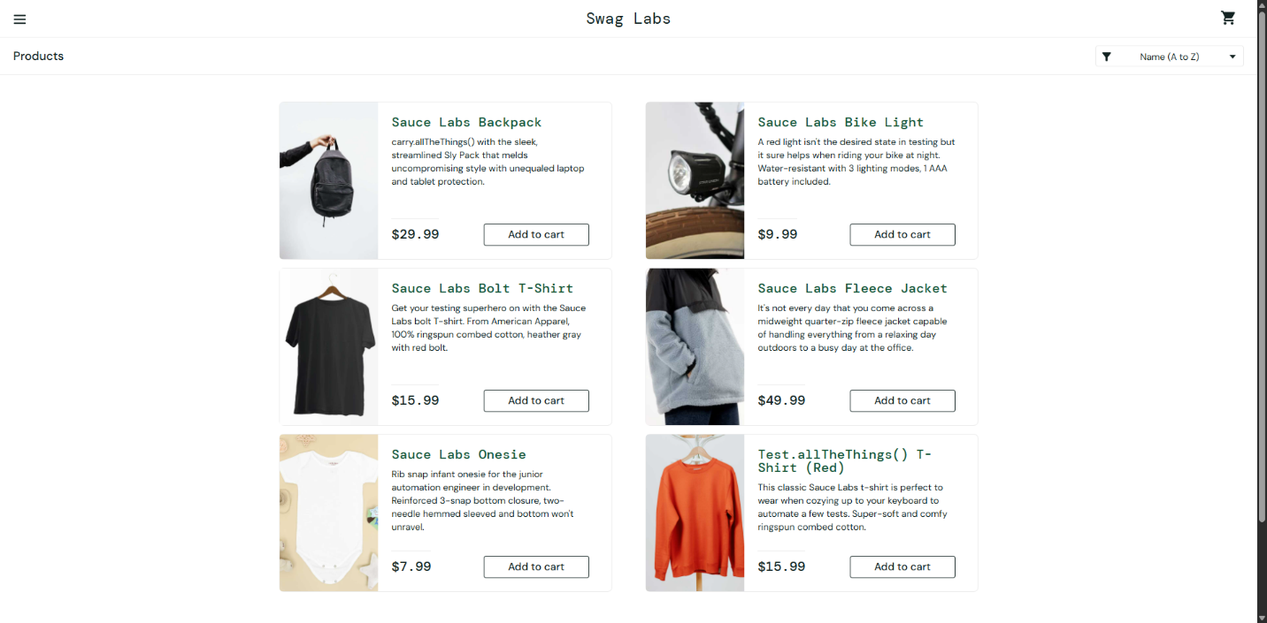
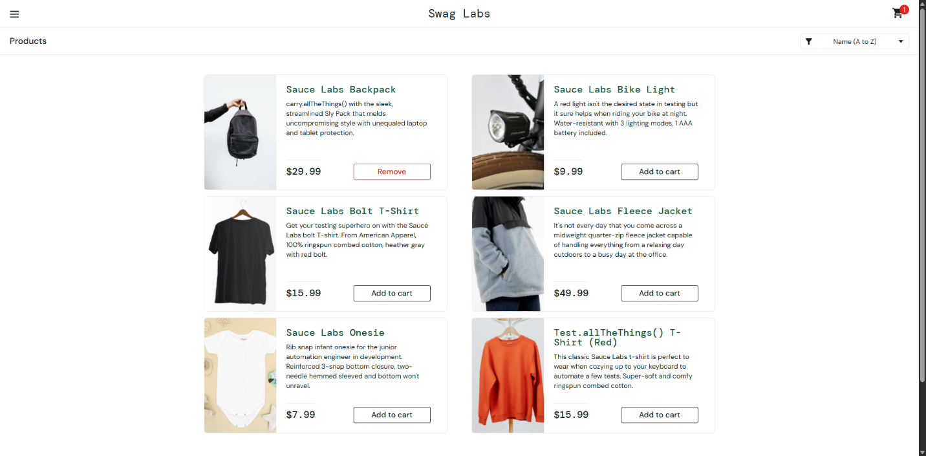
Bài 3:
Đồ thị CFG cho hàm xepLoai
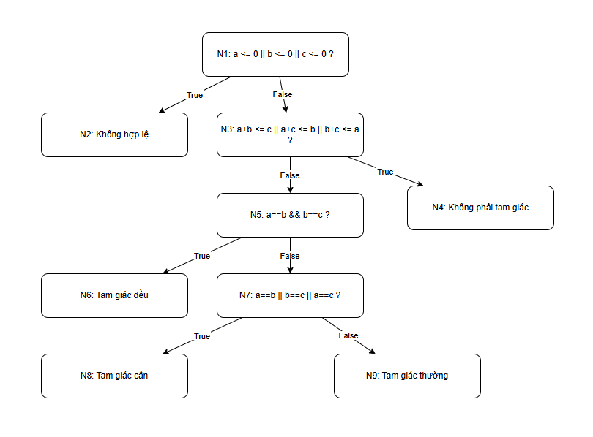
Thiết kế tập test case tối thiểu để đạt 100% Branch Coverage
Nhánh | Mô tả | TC phủ
N1-True | a≤0 hoặc b≤0 hoặc c≤0 | TC1
N1-False | a,b,c >0 | TC2 TC3 TC4 TC5
N2-True | Không tạo thành tam giác | TC2
N2-False | Tạo thành tam giác | TC3 TC4 TC5
N3-True | 3 cạnh bằng nhau | TC3
N3-False | Không phải tam giác đều | TC4 TC5
N4-True | 2 cạnh bằng nhau | TC4
N4-False | Không có cạnh nào bằng | TC5

Branch Coverage = 8 / 8 = 100%
Thiết kế tập test case tối thiểu để đạt 100% Statement Coverage.
Test Case | a | b | c | Lệnh thực thi | Kết quả mong đợi
TC1 | 0 | 3 | 4 | Node1(True) → Exit | Không hợp lệ
TC2 | 1 | 2 | 10 | Node1(False) → Node2(True) → Exit | Không phải tam giác
TC3 | 3 | 3 | 3 | Node1(False) → Node2(False) → Node3(True) → Exit | Đều
TC4 | 3 | 3 | 4 | Node1(False) → Node2(False) → Node3(False) → Node4(True) → Exit | Cân
TC5 | 3 | 4 | 5 | Node1(False) → Node2(False) → Node3(False) → Node4(False) → Exit | Thường

Statement Coverage = 5/5 lệnh = 100%
Bài 3.2:
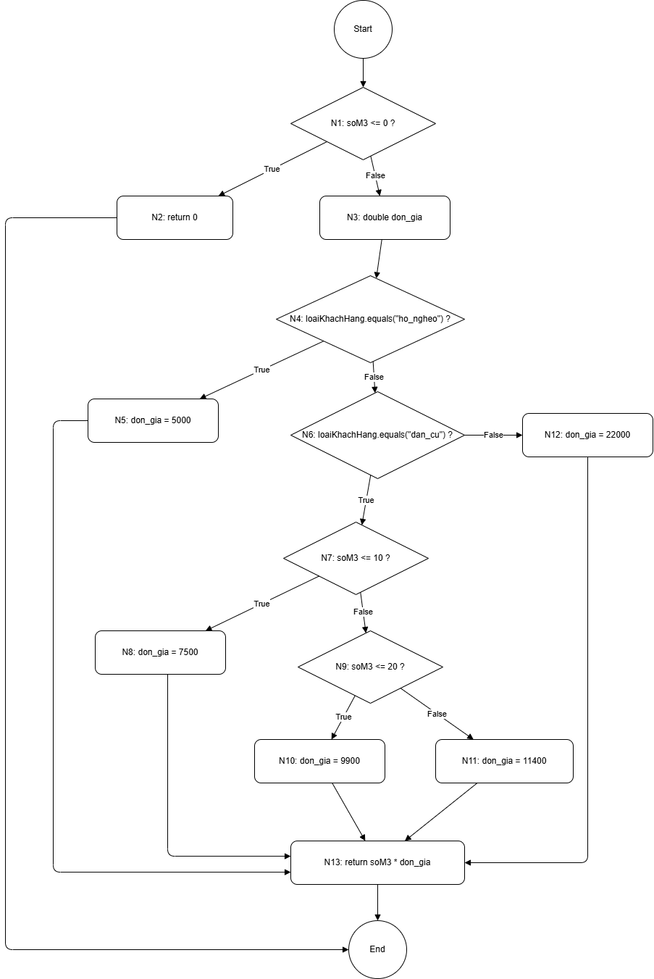
Nhánh (Edge) | Mô tả | TC phủ (Test Case)
N1-True | soM3 <= 0 là ĐÚNG | TC1
N1-False | soM3 > 0 | TC2, TC3, TC4, TC5, TC6
N4-True | loaiKhachHang = "ho_ngheo" | TC2
N4-False | loaiKhachHang != "ho_ngheo" | TC3, TC4, TC5, TC6
N6-True | loaiKhachHang = "dan_cu" | TC3, TC4, TC5
N6-False | loaiKhachHang != "dan_cu" | TC6
N7-True | soM3 <= 10 | TC3
N7-False | soM3 > 10 | TC4, TC5
N9-True | soM3 <= 20 | TC4
N9-False | soM3 > 20 | TC5

Branch Coverage = 10/10 nhánh = 100%
Bảng theo dõi: mỗi TC phủ được những nhánh nào
Test Case | Các nhánh được phủ
TC1 | N1-True
TC2 | N1-False, N4-True
TC3 | N1-False, N4-False, N6-True, N7-True
TC4 | N1-False, N4-False, N6-True, N7-False, N9-True
TC5 | N1-False, N4-False, N6-True, N7-False, N9-False
TC6 | N1-False, N4-False, N6-False

Bài 4.1:
Số lượng decision
Có 7 decision:
- D1: trongLuong <= 0
- D2: vung.equals("noi_thanh")
- D3: trongLuong > 5
- D4: vung.equals("ngoai_thanh")
- D5: trongLuong > 3
- D6: trongLuong > 2
- D7: laMember
Cyclomatic Complexity theo công thức nhanh
$$CC=D+1=7+1=8$$
Kết quả: CC = 8
Sơ đồ cfg:
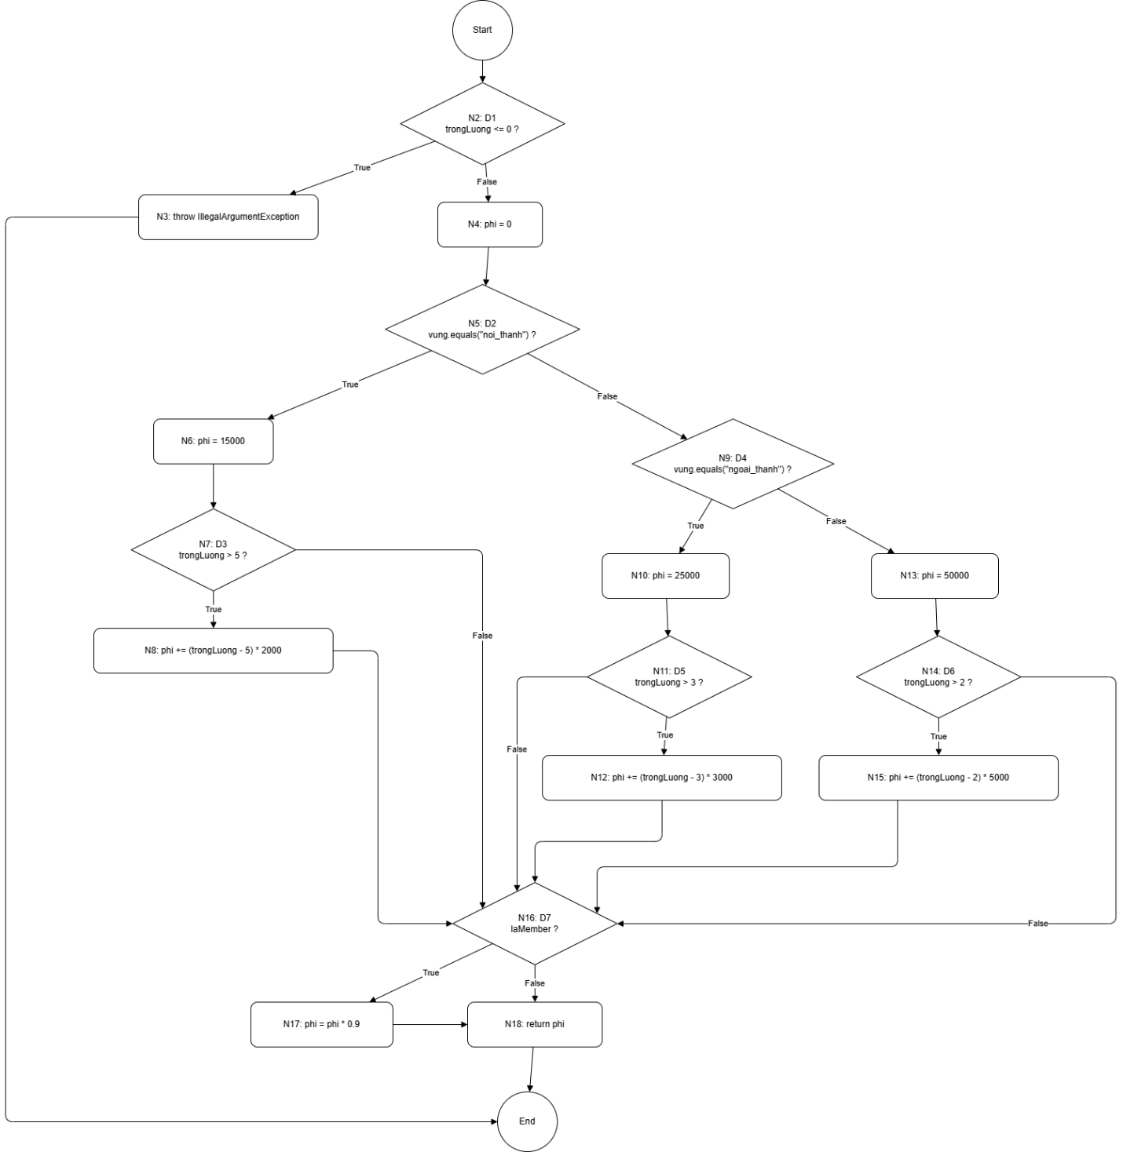
Kiểm tra lại CC = E - N + 2P
Số node
Có 19 node:
$$N=19$$
Số edge
Liệt kê toàn bộ edge:
- E1: N1 → N2
- E2: N2(T) → N3
- E3: N2(F) → N4
- E4: N3 → N19
- E5: N4 → N5
- E6: N5(T) → N6
- E7: N5(F) → N9
- E8: N6 → N7
- E9: N7(T) → N8
- E10: N7(F) → N16
- E11: N8 → N16
- E12: N9(T) → N10
- E13: N9(F) → N13
- E14: N10 → N11
- E15: N11(T) → N12
- E16: N11(F) → N16
- E17: N12 → N16
- E18: N13 → N14
- E19: N14(T) → N15
- E20: N14(F) → N16
- E21: N15 → N16
- E22: N16(T) → N17
- E23: N16(F) → N18
- E24: N17 → N18
- E25: N18 → N19
$$E=25$$
Số thành phần liên thông
Đồ thị có 1 thành phần liên thông:
$$P=1$$
Tính lại CC
$$CC=E-N+2P=25-19+2(1)=8$$
Kết quả khớp:
$$CC=8$$Thiết kế tập Basis Path
Vì:
$$CC=8$$
nên cần 8 đường cơ sở độc lập.
4.1. Liệt kê 8 basis path
Path 1
Đường đi:
N1 → N2(T) → N3 → N19
Ý nghĩa: trọng lượng không hợp lệ
Path 2
Đường đi:
N1 → N2(F) → N4 → N5(T) → N6 → N7(F) → N16(F) → N18 → N19
Ý nghĩa: nội thành, không phụ thu cân nặng, không member
Path 3
Đường đi:
N1 → N2(F) → N4 → N5(T) → N6 → N7(T) → N8 → N16(F) → N18 → N19
Ý nghĩa: nội thành, có phụ thu cân nặng, không member
Path 4
Đường đi:
N1 → N2(F) → N4 → N5(F) → N9(T) → N10 → N11(F) → N16(F) → N18 → N19
Ý nghĩa: ngoại thành, không phụ thu cân nặng, không member
Path 5
Đường đi:
N1 → N2(F) → N4 → N5(F) → N9(T) → N10 → N11(T) → N12 → N16(F) → N18 → N19
Ý nghĩa: ngoại thành, có phụ thu cân nặng, không member
Path 6
Đường đi:
N1 → N2(F) → N4 → N5(F) → N9(F) → N13 → N14(F) → N16(F) → N18 → N19
Ý nghĩa: tỉnh khác, không phụ thu cân nặng, không member
Path 7
Đường đi:
N1 → N2(F) → N4 → N5(F) → N9(F) → N13 → N14(T) → N15 → N16(F) → N18 → N19
Ý nghĩa: tỉnh khác, có phụ thu cân nặng, không member
Path 8
Đường đi:
N1 → N2(F) → N4 → N5(T) → N6 → N7(F) → N16(T) → N17 → N18 → N19
Ý nghĩa: nội thành, không phụ thu cân nặng, có member
Path | trongLuong | vung | laMember | Kết quả mong đợi
P1 | -1 | "noi_thanh" | false | Ném IllegalArgumentException
P2 | 4 | "noi_thanh" | false | 15000
P3 | 6 | "noi_thanh" | false | 17000
P4 | 2 | "ngoai_thanh" | false | 25000
P5 | 5 | "ngoai_thanh" | false | 31000
P6 | 1.5 | "tinh_khac" | false | 50000
P7 | 4 | "tinh_khac" | false | 60000
P8 | 4 | "noi_thanh" | true | 13500

Bài 4.2:
Kết quả test
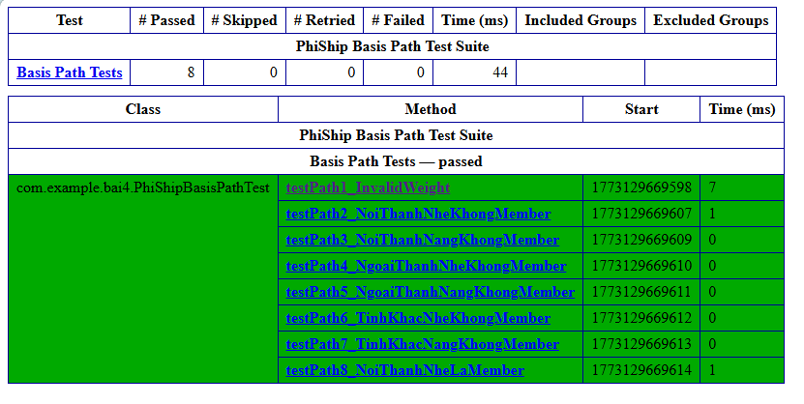
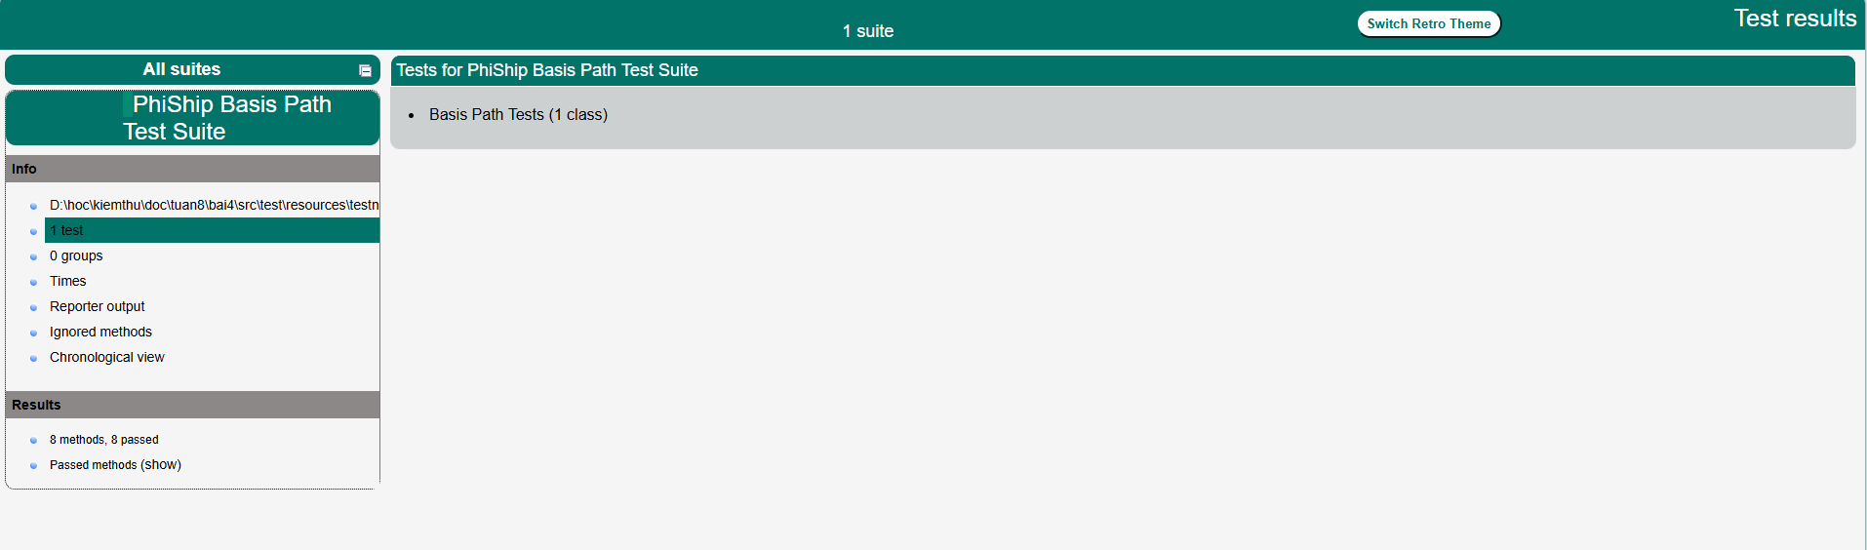
Bài 5.1:
Xác định tất cả điều kiện đơn
Có 4 điều kiện đơn:
- A: tuoi >= 22
- B: thuNhap >= 10_000_000
- C: coTaiSanBaoLanh
- D: dienTinDung >= 700
Bảng chân trị cho toàn bộ biểu thức
Ta lập bảng chân trị cho:
$$Y=(A∧B)∧(C∨D)$$
Dòng | A | B | C | D | A&&B | C||D | Y
1 | F | F | F | F | F | F | F
2 | F | F | F | T | F | T | F
3 | F | F | T | F | F | T | F
4 | F | F | T | T | F | T | F
5 | F | T | F | F | F | F | F
6 | F | T | F | T | F | T | F
7 | F | T | T | F | F | T | F
8 | F | T | T | T | F | T | F
9 | T | F | F | F | F | F | F
10 | T | F | F | T | F | T | F
11 | T | F | T | F | F | T | F
12 | T | F | T | T | F | T | F
13 | T | T | F | F | T | F | F
14 | T | T | F | T | T | T | T
15 | T | T | T | F | T | T | T
16 | T | T | T | T | T | T | T

Chọn tập test case đạt Condition Coverage:
TC | tuoi | thuNhap | coTaiSanBaoLanh | dienTinDung | Kết quả mong đợi
TC1 | 25 | 12000000 | true | 750 | true
TC2 | 20 | 8000000 | false | 650 | false

Chọn cặp dòng chứng minh độc lập
Điều kiện A
Giữ nguyên: B = T, C = F, D = T
- Dòng X1: A = F, B = T, C = F, D = T
$$Y=(F∧T)∧(F∨T)=F$$
- Dòng X2: A = T, B = T, C = F, D = T
$$Y=(T∧T)∧(F∨T)=T$$
=> Khi chỉ thay đổi A, kết quả đổi từ F → T
=> A ảnh hưởng độc lập
Điều kiện B
Giữ nguyên: A = T, C = F, D = T
- Dòng X2: A = T, B = T, C = F, D = T
$$Y=T$$
- Dòng X3: A = T, B = F, C = F, D = T
$$Y=(T∧F)∧(F∨T)=F$$
=> Khi chỉ thay đổi B, kết quả đổi từ T → F
=> B ảnh hưởng độc lập
Điều kiện C
Giữ nguyên: A = T, B = T, D = F
- Dòng X4: A = T, B = T, C = F, D = F
$$Y=(T∧T)∧(F∨F)=F$$
- Dòng X5: A = T, B = T, C = T, D = F
$$Y=(T∧T)∧(T∨F)=T$$
=> Khi chỉ thay đổi C, kết quả đổi từ F → T
=> C ảnh hưởng độc lập
Điều kiện D
Giữ nguyên: A = T, B = T, C = F
- Dòng X4: A = T, B = T, C = F, D = F
$$Y=F$$
- Dòng X2: A = T, B = T, C = F, D = T
$$Y=T$$
=> Khi chỉ thay đổi D, kết quả đổi từ F → T
=> D ảnh hưởng độc lập
TC | tuoi | thuNhap | coTaiSanBaoLanh | dienTinDung | Kết quả mong đợi
TC1 | 20 | 12000000 | false | 750 | false
TC2 | 25 | 12000000 | false | 750 | true
TC3 | 25 | 8000000 | false | 750 | false
TC4 | 25 | 12000000 | false | 650 | false
TC5 | 25 | 12000000 | true | 650 | true

Cặp test chứng minh MC/DC cho từng điều kiện
Điều kiện | Cặp test | Giải thích
A | TC1 – TC2 | Chỉ A đổi F→T, Y đổi F→T
B | TC2 – TC3 | Chỉ B đổi T→F, Y đổi T→F
C | TC4 – TC5 | Chỉ C đổi F→T, Y đổi F→T
D | TC4 – TC2 | Chỉ D đổi F→T, Y đổi F→T

Bài 6.1:
Sơ đồ cfg:
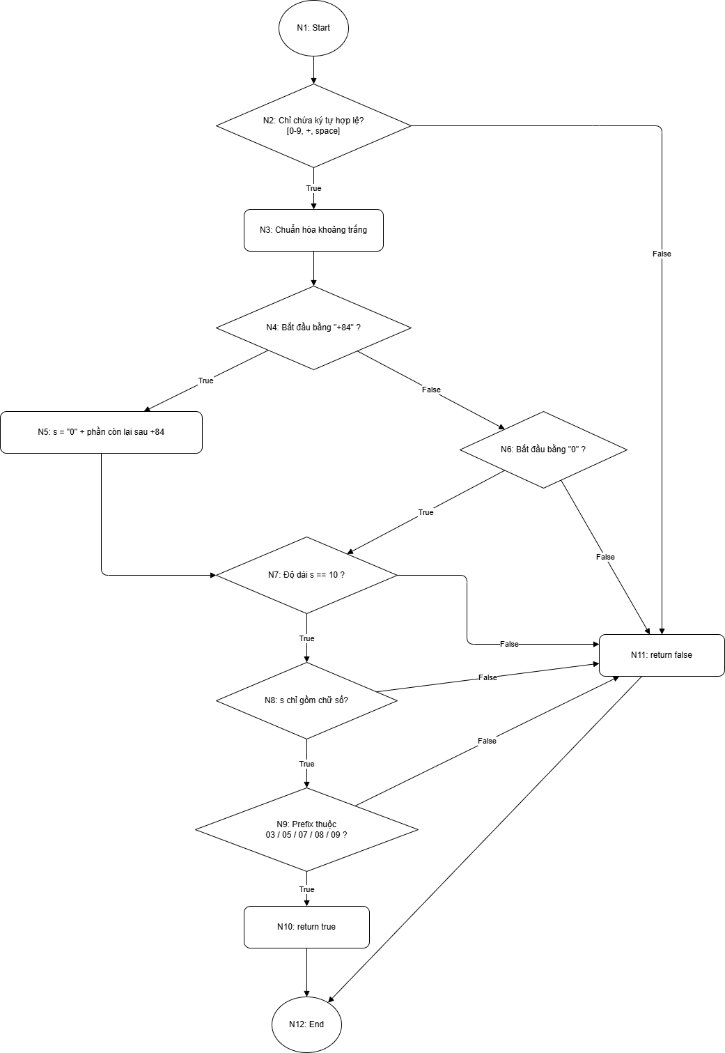
Có 6 decision:
- D1: ký tự hợp lệ?
- D2: bắt đầu bằng +84?
- D3: bắt đầu bằng 0?
- D4: độ dài bằng 10?
- D5: chỉ gồm chữ số?
- D6: prefix hợp lệ?
Theo công thức nhanh:
$$CC=D+1=6+1=7$$
Cyclomatic Complexity = 7
Số test case tối thiểu theo Basis Path: 7
Báo cáo corverage:
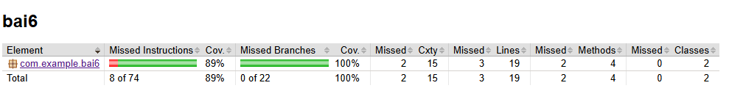
Bài 6.2:
Đồ thị cfg
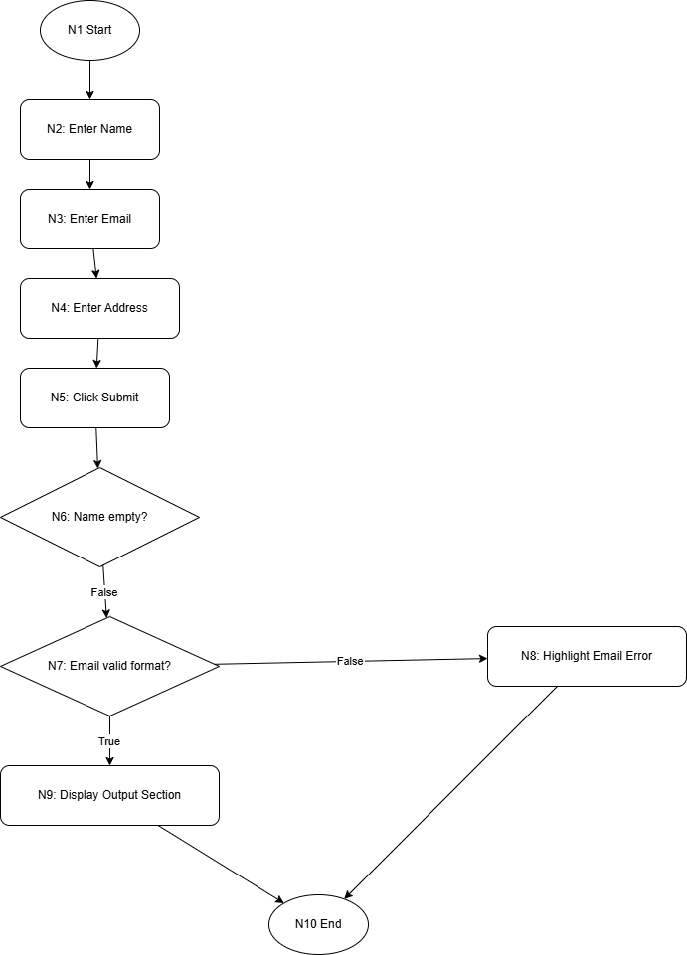
Bài 7.1:
Đồ thị cfg:
